***Flower Run***

***Lab Goal:***

The goal of this lab is to solve the puzzle by using a variety of different ideas. The ideas can include methods, while loops, hop, plant, and pick as wells as turning right and left

***Lab Description:***

This lab will puzzle you because you need to think of a way to use a while loop inside of a method with all using turn right, turn left, hop, plant, and pick. In this lab you need to go down each row picking up the flowers and then the next row you need to plant a row of flowers and repeat this all the way to the end until you’re done.

***Files needed:***

RyanBlakemanJerooProject.jsc

RyanBlakemanJerooProject.jev

***Algorithm help:***

**Pre:**

-Pick all the flowers it finds

-Don’t let the Jeroo hit the water

-Plant flowers in the rows that don’t have flowers

**Post:**

-All flowers should be moved over a row

-The Jeroo should finish in the top right corner looking north

-Jeroo is not in the water

***Starting Screen:***

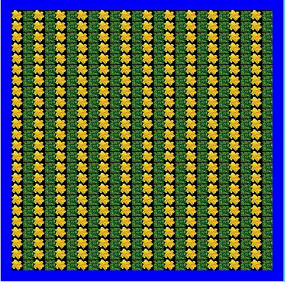

***Finishing Screen:***

